I’ve been trying to connect a LAN8720 ethernet board on a ESP32 Dev module and everywhere I look, I just can’t seem to get all the info to get it to work first shot!

There’s the physical plugging of them together, using the onboard 50 MHz oscilator or using the ESP32 to generate the 50 MHz clock, using the GPIO 0 or another, and I’ve tried almost all of them including using a transistor to isolate the clock out of the LAN8720 board connecting to GPIO0 of the ESP32 and using another GPIO with a delay to activate the transistor so that the ESP32 will boot up normally at every boot or reboot.  
Here’s what I found to be the simplest solution that I managed to make work and it works every time I boot or reboot the ESP32.  
I hope this will help someone else!

* On the LAN8720 ethernet board, find the the onboard oscilator and place a jumper between the Enable pin and the GND pin.

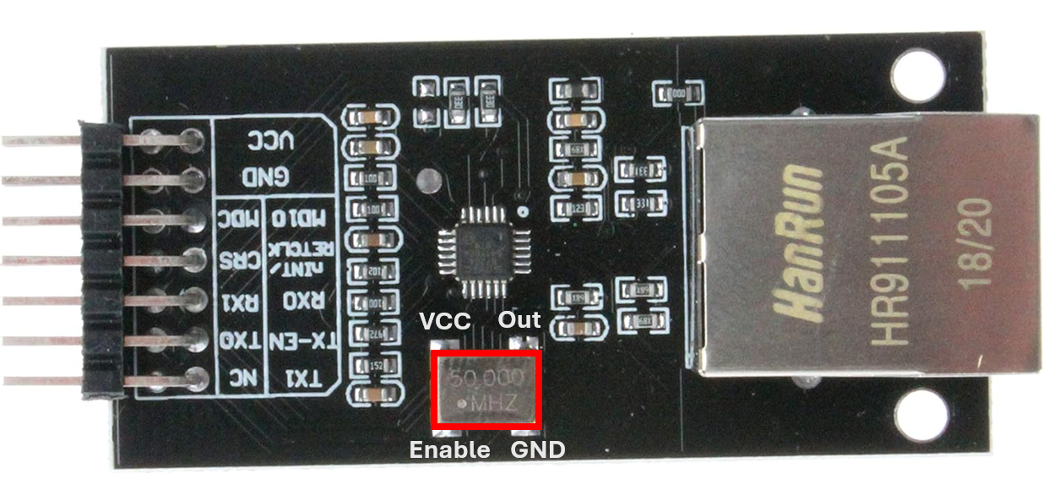

* Connect these pins of the LAN8720 to the GPIO of the ESP32

Lan8720 ESP32

Int/retclk Gpio 17

MDIO Gpio 18

TxD0 Gpio 19

TxEN Gpio 21

TxD1 Gpio 22

MDC Gpio 23

RxD0 Gpio 25

RxD1 Gpio 26

CRS Gpio 27

VCC 3.3v

GND GND



Using these values in my code is how I got it to work:

<ETH.h>

ETH_TYPE ETH_PHY_LAN8720

ETH_ADDR 1

ETH_POWER_PIN -1

ETH_CLK_MODE ETH_CLOCK_GPIO17_OUT

ETH_MDC_PIN 23

ETH_MDIO_PIN 18

Here’s the complete code:  
  
#include <ETH.h>

#define ETH_TYPE ETH_PHY_LAN8720

#define ETH_ADDR 1

#define ETH_POWER_PIN -1

#define ETH_CLK_MODE ETH_CLOCK_GPIO17_OUT

#define ETH_MDC_PIN 23

#define ETH_MDIO_PIN 18

// Configure static IP

IPAddress IP(192, 168, 1, 100);

IPAddress GW(192, 168, 1, 1);

IPAddress SN(255, 255, 255, 0);

IPAddress DNS(192, 168, 1, 10);

void setup() {

  Serial.begin(115200);

  // Initialize Ethernet with custom PHY

  if (!ETH.begin(ETH_PHY_LAN8720, ETH_ADDR, ETH_MDC_PIN, ETH_MDIO_PIN, ETH_POWER_PIN, ETH_CLK_MODE)) {

    Serial.println("Failed to initialize Ethernet");

    return;

  }

  ETH.config(IP, GW, SN, DNS);

  Serial.println("Ethernet initialized");

}

void loop() {

  if (ETH.linkUp()) {

    Serial.print("IP Address: ");

    Serial.println(ETH.localIP());

    Serial.print("Subnet Mask: ");

    Serial.println(ETH.subnetMask());

    Serial.print("Gateway IP: ");

    Serial.println(ETH.gatewayIP());

    Serial.print("DNS IP: ");

    Serial.println(ETH.dnsIP());

  } else {

    Serial.println("Ethernet link down");

  }

  delay(1000);

}